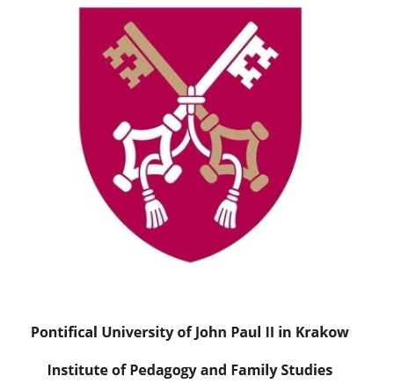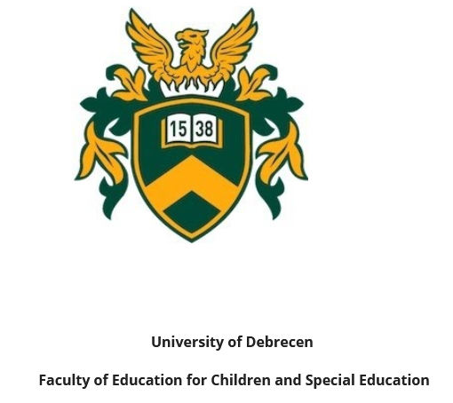

EDUCATION IN THE FAMILY – THE FAMILY IN EDUCATION

III. International Conference on the Family and Education
30 May 2023
We invite researchers, academic teachers, PhD students and people working with families to register for the conference. If you would like to attend the conference as a listener and receive a certificate, please fill out the registration form available below.
Deadline for registration:
April 30th, 2023

The conference will organized on-site. The location of the conference will be at the Faculty of Education for Children and Special Educational Needs of the University of Debrecen (Hungary).
We are pleased to invite you to attend the conference devoted to family and education. Despite numerous crises which have been affecting the family, it still remains the basic educational environment. As a social group, it is also part of the national educational system which has been undergoing dynamic changes. This dependence shows considerable educational potential which may offer children, teenagers, adults and the oldest family members opportunities for development. We are aware of deficiencies and obstacles in the process of education in the family. We notice great needs in the social dimension of education. Therefore, it is crucially important to organise academic meetings and have discussions on the issue.
Main topics:
1. Education in the family
2. Family in the educational system
3. Social aspects of education
4. Education for ethnic minorities
5. Student session

Official language of the conference: English

Applicants will be informed about abstracts by 10 May. All the accepted abstracts will be published in an abstracts book with an ISBN number.

Publishing conference papers
Conference papers can be published in Különleges Bánásmód [Special Treatment] which is an online, interdisciplinary Open Access journal run by the University of Debrecen, Hungary. Every paper published in Különleges Bánásmód has its DOI number (Digital Object Identifier). Különleges Bánásmód [Special Treatment] is in the process of being involved in Scopus Content Selection. (more info: https://ojs.lib.unideb.hu/kulonlegesbanasmod). Participants will be informed about publishing papers later.

Conference Committee
Committee chairs:
- Gortka-Rákó Erzsébet, Associate Professor at University of Debrecen
- Godawa Grzegorz, Associate Professor at Pontifical University of John Paul II in
Cracow
Scientific committee:
- Majerek Bożena, Associate Professor at Pontifical University of John Paul II in
Cracow
- Lubińska-Kościółek Elżbieta, Assistant Professor at Pontifical University of John Paul II in Cracow
- Bocsi Veronika, Associate Professor at the University of Debrecen
- Galán Anita, Associate Professor at University of Debrecen
Organizing committee:
- Nemes Magdolna, Associate Professor at University of Debrecen
- Ochońska Magdalena, PhD, Pontifical University of John Paul II in Cracow

Fee: Participation in the conference is 50 EUR.
Registration for speakers:
www.http://pedagogy-conference.eu/

Contact: nemesm@ped.unideb.hu

We look forward to seeing you at Education in the family – The family in education.
Sincerely,
Gortka-Rákó Erzsébet Godawa Grzegorz
Associate Professor Associate Professor
University of Debrecen Pontifical University of John Paul II in Krakow

